Operational Concept Description (OCD)

Improvement on VITA website

Team #8

Team members | Primary Role | Secondary Role
Youn Kyu Lee | Project Manager | Life Cycle Planner, Web Designer
Melissa Roemmele | Operational Concept Engineer | Requirements Engineer,  Web Designer
JungYoun Ku | Requirement Engineer | Feasibility Analyst
Jeonghoon Yun | Prototyper, Builder | Software Architect, Trainer
Woochan Jun | Software Architect | Prototyper, Builder
Hiram Garcia | IIV&V | Shaper, Tester

11/20/2012

Version History
Date | Author | Version | Changes made | Rationale
09/28/12 | Ku; Melissa | 1.0 | - Initial template has been made  - Shared Vision has been added.  - Information on current system has been added  - Section 1.1, 1.2, 2.1, 2.3, 3.1 have been completed | - To organize operational concept design about team #8 project
10/14/12 | Melissa | 1.1 | - Shared Vision has been updated | - Made corrections based on instructor feedback
10/14/12 | Melissa | 2.0 | - System Transformation has been added  - All sections have been completed. | - Continued organization of operational concept design for foundations phase
10/28/12 | Melissa | 2.1 | - Updated Program Model, Benefits Chain, System Boundary, & Capability Goals | - Made corrections based on instructor feedback
11/5/12 | Melissa | 3.0 | - Added Section 4: Reformed System Transformation to reflect re-scoping of requirements | - Project time frame was reduced from 2 semesters to 1 semester, so current document reflects changes in project plan
11/20/12 | Melissa | 4.0 | - Moved Section 4 contents to earlier in document and removed Section 4 | - Instructor provided feedback that updated project plan was unclear because it was an appendix to previous OCD, so latest version is intended to provide clarity

Table of Contents
Operational Concept Description (OCD) i
Version History ii
Table of Contents iii
Table of Tables iv
Table of Figures v
1. Introduction 1
1.1 Purpose of the OCD 1
1.2 Status of the OCD 1
2. Shared Vision 2
2.1 Benefits Chain 3
2.2 System Capability Description 3
2.3 System Boundary and Environment 4
3. System Transformation 5
3.1 Information on Current System 5
3.2 System Objectives, Constraints and Priorities 7
3.3 Proposed New Operational Concept 10
3.4 Organizational and Operational Implications 12

Table of Tables
Table 1: The Program Model 2
Table 2: The Infrastructure 5
Table 3: Capability Goals 7
Table 4: Level of Service Goals 8
Table 5: Relation to Current System 9

Table of Figures
Figure 1: Benefits Chain Diagram of Volunteer and Client Scheduling System 3
Figure 2: System Boundary and Environment Diagram of Volunteer and Client Scheduling System 4
Figure 3: Current Business Workflow of VITA 6
Figure 4: Element Relationship Diagram of VITA Website 10
Figure 5: Business Workflow Diagram for Improved VITA System 11

Introduction

Purpose of the OCD
This OCD document is for identifying the shared vision and goals of the stakeholders of the Project #8, Improvement on VITA website. The success-critical stakeholders of the project are USC VITA Presidents, the main client of the project; the other VITA committee members, as maintainer; VITA clients and volunteers, as users; Team 8 members, as developers.

Status of the OCD
This document is the version 4.0 in the Testing phase. The team has finished analyzing current system and established new operational concept for the proposed system. Previous versions of this document described the capabilities, goals, and benefits of the original project plan going into the team’s ARB session in November 2012. Based on the outcome of the ARB review, the requirements for the current project have been reformed. We have reduced the capabilities, level of service, and operational goals that will be addressed by the current project. In Section 3.2, we specifically identify which features will be addressed by the current project; these components appear in bold text. Please note that much information throughout this document, particularly diagrams, pertain to the original project plan. We have not altered these diagrams in case the original project plan is implemented at some point in the future, so future developers will be able to reference this document. Look for the bold text in Section 3.2 to clarify which capabilities and goals will be delivered with the current project.

Shared Vision
Table 1: The Program Model
Assumptions
- Users (VITA committee, VITA clients, and volunteers) are trained to utilize the scheduling features
- Continuously growing participation of VITA clients and volunteers
- Growing use of website brings more users
- Increase in users contributes to better reputation of VITA organization
Stakeholders | Initiatives | Value Propositions | Beneficiaries
- Developers  - VITA clients  - VITA volunteers  - Client(VITA committee)  - IIV&V | - Develop new scheduling feature for client and volunteers  - Develop volunteer application processing via website  - Develop interface for viewing/editing client and volunteer schedules  - Provide instructions on website for how to become involved with VITA | - Improved scheduling process  - Increased reputation of VITA organization  - Increased productivity  - Increased VITA website use | - Client(VITA committee)  - VITA clients  - VITA volunteers

Benefits Chain

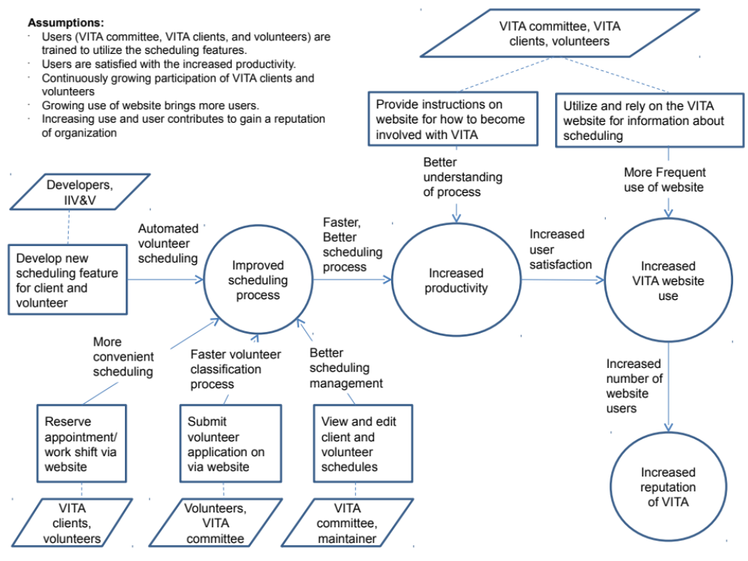
Figure 1: Benefits Chain Diagram of Volunteer and Client Scheduling System

System Capability Description
The main goal of the project is to build the website for USC VITA organization. Mostly, VITA committee, their clients, and volunteers are going to use this website. There are several features that will be satisfied when the team finishes developing the new VITA website; clients will be able to reserve appointments via the website; potential volunteers will be able to apply to be a tax return volunteer and submit an work availability via the website; VITA committee members will be able to view and edit the whole schedules of volunteers and their clients. These features will add value for the VITA organization by saving them a lot of time, because currently a lot of time is spent on scheduling both clients and volunteers. UCLA VITA has been on established longer than USC VITA. For that reason our client would like us to use the UCLA VITA website as a reference point for our development but would ultimately like the USC VITA website to be more professional and easier to use than the UCLA VITA website.

System Boundary and Environment

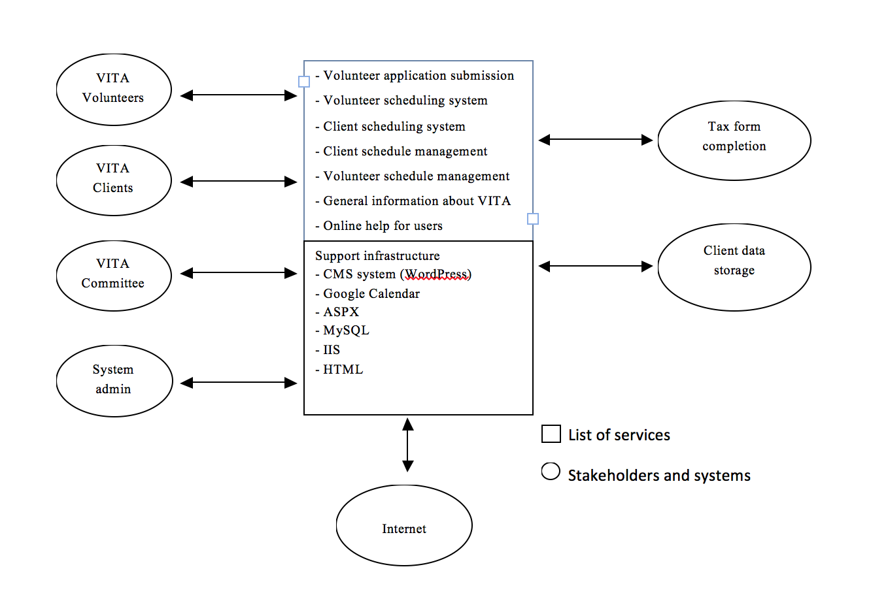
Figure 2: System Boundary and Environment Diagram of Volunteer and Client Scheduling System

System Transformation

Information on Current System

Infrastructure
VITA doesn’t have any server machine to manage current webpage and own database to store user data. They just use Excel to clarify the schedules and appointments by themselves. Since current VITA webpage is designed using WordPress (URL: http://uscvita.wordpress.com/). To maintain and manage it, they have to keep an account for WordPress.

Table 2: The Infrastructure
Hardware | - Six Microsoft Windows based machine. (Most of them are very old.)
Software | - Microsoft Office 2010 (Excel, Word, and Powerpoint)  - COTS : WordPress  - Web browsers: Chrome, Firefox, Internet Explorer, Safari
Development Platform | - Microsoft Windows

Artifacts
- Images and pictures data: USC VITA logo, images and photos related to USC VITA’s activities.
- Application information: Application information for prospective volunteers.
- Training session data: Video contents and documented guideline for training session.
- General information document: USC VITA’s unique objectives, goals, history and contacts.
- Frequently asked questions document: Frequently asked questions which help users including prospective volunteers and clients understand USC VITA service and related information.
- Appointment form: Required information clients need to fill out to make an appointment

Current Business Workflow
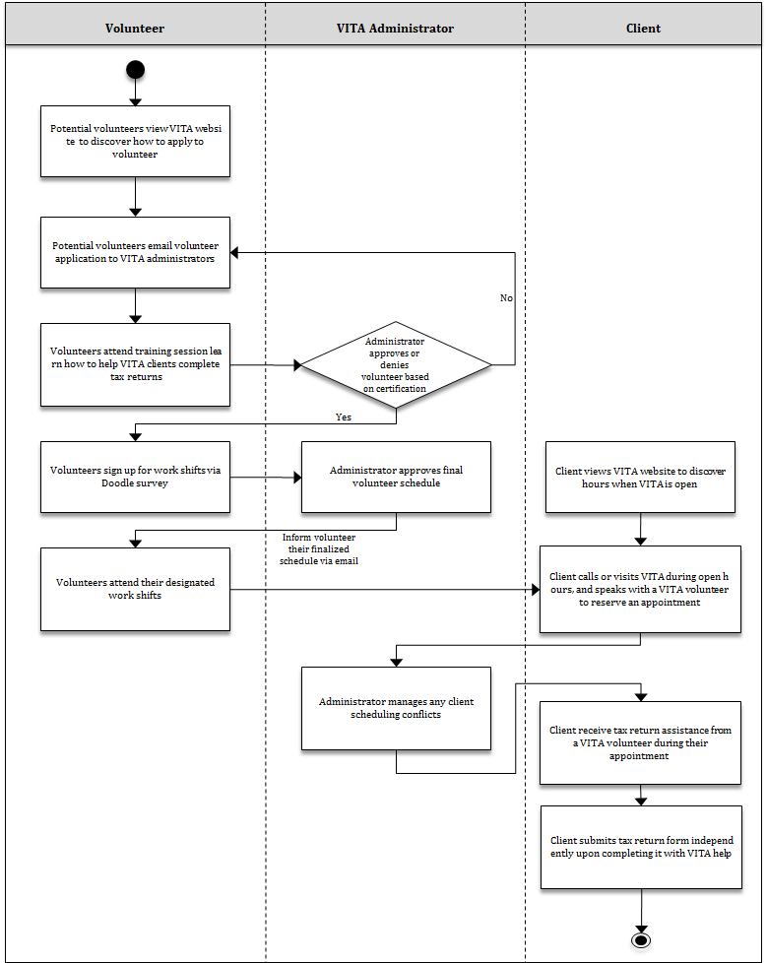
Figure 3: Current Business Workflow of VITA

System Objectives, Constraints and Priorities
As described in Section 1.2, as of the November 2012 ARB session, the project plan was changed to reduce the scope of the project. In tables 3.2.1, 3.2.2, and 3.2.3 below, the bold text indicates the project components that will be addressed in the current project. Components not bolded will not be addressed by the current project, but they are still described for the sake of future projects that may pursue these capabilities.

Capability Goals
Table 3: Capability Goals
Capability Goals | Priority Level
OC-1 Client Appointment Scheduling: The system is capable of enabling clients to view available appointment times and automatically reserve one of these available times through the VITA website. | <<Must have>>
OC-2 Volunteer Work Scheduling: The system is capable of enabling volunteers to view available work shifts and automatically sign up for their preferred shifts. | <<Must have>>
OC-3 Volunteer Application Processing: The system is capable of enabling potential volunteers to automatically submit applications to become a VITA volunteer. | <<Should have>>
OC-4 Schedule Management: The system is capable of enabling VITA administrators to view and edit all client appointments and volunteer work shifts. | <<Must have>>
OC-5 Schedule Configuration: The system is capable of enabling VITA administrators to configure available slots in both the client and volunteer schedules (i.e., administrators can determine which days/times volunteers/clients can reserve and how long these reserved periods will last) | <<Must have>>
OC-6 New Web Hosting: The website will be transferred from the wordpress.com web server to a new web host that supports the above capabilities. | <<Must have>>
OC-7 Information Distribution: The website is capable of informing users of how to engage in the VITA workflow (i.e. how to schedule an appointment, how to submit a volunteer application, and how to sign up for a volunteering shift, as well as VITA’s mission statement and general FAQ) | <<Must have>>

Level of Service Goals
Table 4: Level of Service Goals
Level of Service Goals | Priority Level
LOS-1: The VITA website must be accessed on the client’s preferred domain name (e.g. uscvita.org). | <<Must have>>
LOS-2: The design of the VITA website should look professional (i.e. as professional, or more professional-looking than UCLA VITA’s website). | <<Should have>>
LOS-3: The user interface of the VITA website should be highly intuitive and easy to use (i.e. it should be obvious for potential clients to understand how to schedule an appointment). | <<Must have>>

Organizational Goals

OG-: Increase the ease and convenience of scheduling a client appointment.
OG-2: Increase the number of clients that use VITA services.
OG-3: Optimize volunteer scheduling such that the majority of volunteers have their preferred work schedule.
OG-4: Increase the number of VITA volunteers.
OG-5: Decrease time spent by VITA administrators planning and managing volunteer schedules.
OG-6: Decrease time spent by VITA administrators helping clients to book appointments.

Constraints
CO-1: Strict Monetary Budget: The cost of all components of the system, including domain name purchasing and web hosting, should not exceed $50 total for the year.
CO-2: Content Management System: The website must continue to interface with WordPress, the content management system that VITA administrators rely on to edit and update website content.

Relation to Current System
Table 5: Relation to Current System
Capabilities | Current System | New System
Roles and Responsibilities | VITA administrators must manually resolve any volunteer/client scheduling conflicts (i.e. ensure only a certain number of clients are scheduled per appointment slot). | System will automatically ensure that scheduling conflicts are avoided.
User Interactions | Clients must wait until VITA office is open to schedule an appointment. They must then speak with a volunteer who will manually schedule them. | Clients can schedule an appointment anytime via an automated scheduling agent on the website.
Infrastructure | Administrators and volunteers must maintain Excel spreadsheets with client and volunteer schedules, and must make sure their copies of these documents are the most up-to-date version. | Client and volunteer schedules will be automatically updated as they are changed, and one copy of each schedule will be shared between administrators and volunteers. No need to manually sync documents.
Stakeholder Essentials and Amenities | Website is primarily a tool for advertising information about VITA, but it is not essential to organization workflow. | Website will occupy a central role in the organization workflow.
Future Capabilities | Limited opportunity for client and volunteer expansion due to manual scheduling process. | VITA will be able to accommodate more volunteers and clients since they can be readily scheduled with minimal conflicts.

Proposed New Operational Concept

Element Relationship Diagram

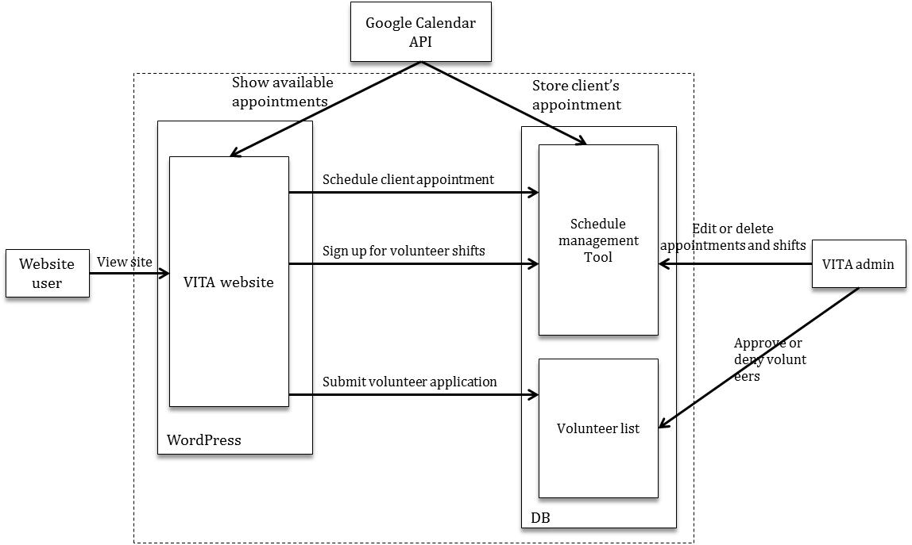
Figure 4: Element Relationship Diagram of VITA Website

Business Workflows
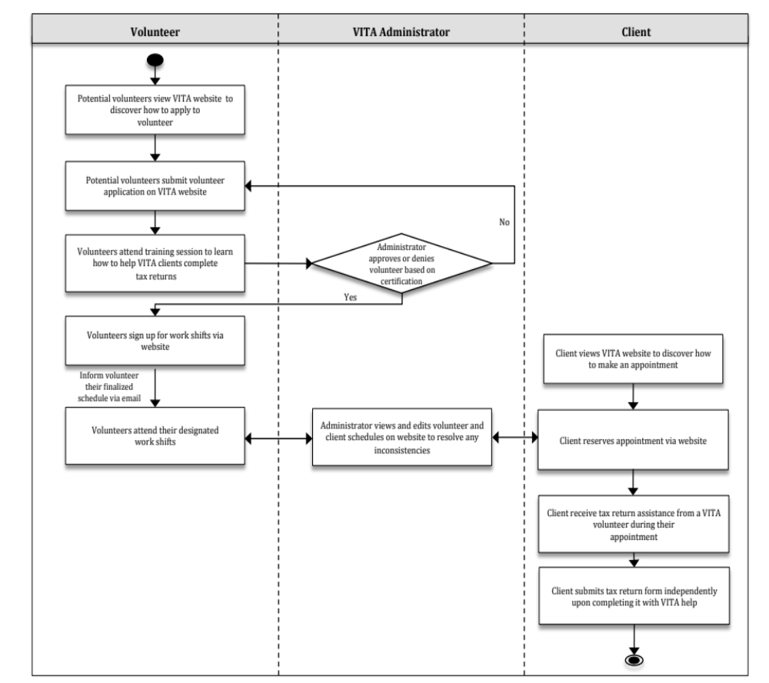
Figure 5: Business Workflow Diagram for Improved VITA System

Organizational and Operational Implications

Organizational Transformations
- VITA administrators will need to be responsible for enabling and disabling certain features of the website depending on the time of year. For instance, volunteers should only be allowed to submit applications prior to the beginning of tax season, and clients should only be allowed to schedule appointments prior to the end of tax season.
- Because of increased reliance on automatic client scheduling via the website, volunteers and administrators will be less responsible for determining available appointment times and ensuring only a certain number of clients are booked per appointment slot. This will enable volunteers to spend more time reviewing tax returns with clients. This will enable administrators to spend more time with tasks like increasing awareness of VITA among those who could benefit from its services.
- VITA administrators need to learn how to take care of the system.

Operational Transformations
- Clients can reserve appointments through the USC VITA website automatically rather than calling or visiting the office to speak with a volunteer who will schedule them.

- Potential volunteers can fill out an application through the website rather than emailing their information to a VITA administrator. Applying via the website ensures that the volunteer provides the necessary application information, which cuts down on email communication between volunteers and administrators to resolve missing application information.

- VITA administrators and volunteers will no longer need to spend significant time finding available appointment times for clients and resolving scheduling conflicts, since the new scheduling system will automatically take care of this.

